ScheduleOnce Sign-Up Instructions
- Check your email for your OnceHub Mailer email welcoming you to the team!
- Click the Sign in to your account button:
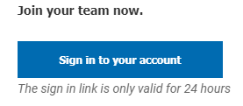
- Create your password:
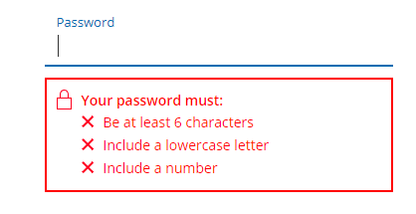
- Click on the link to Go to ScheduleOnce
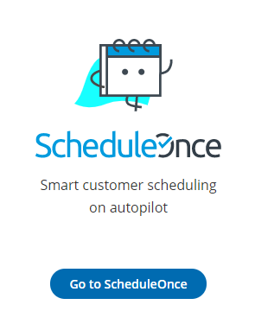
To Connect to an Exisiting Calendar (Google, iCal, Exchange, etc.)
- Click on the cirlce icon with your initials in the top right corner of the page and then click on Calendar Connection.
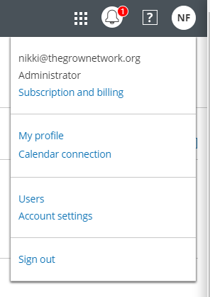
- Select the calendar type that you use by clicking Connect:
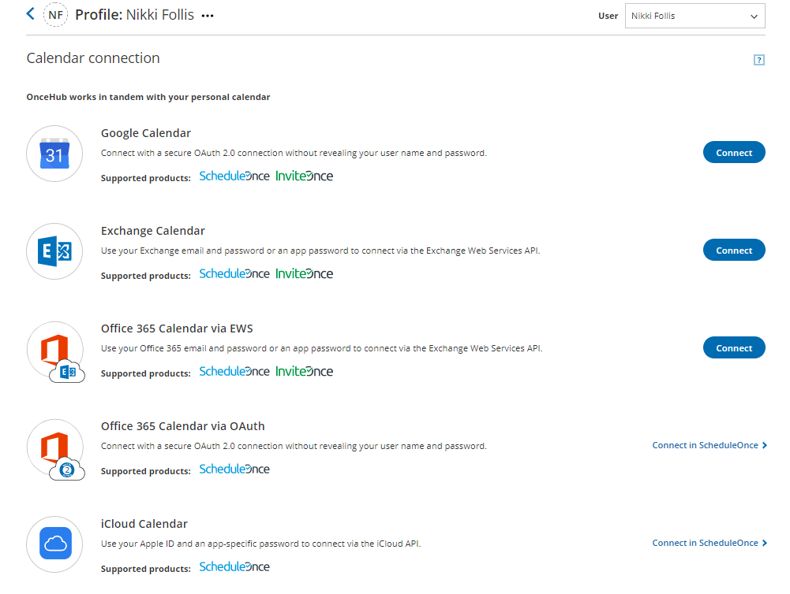
- Follow the step-by-step instructions to finish the calendar connection.
- Once the calendar is connected, click on Continue Setup next to ScheduleOnce:
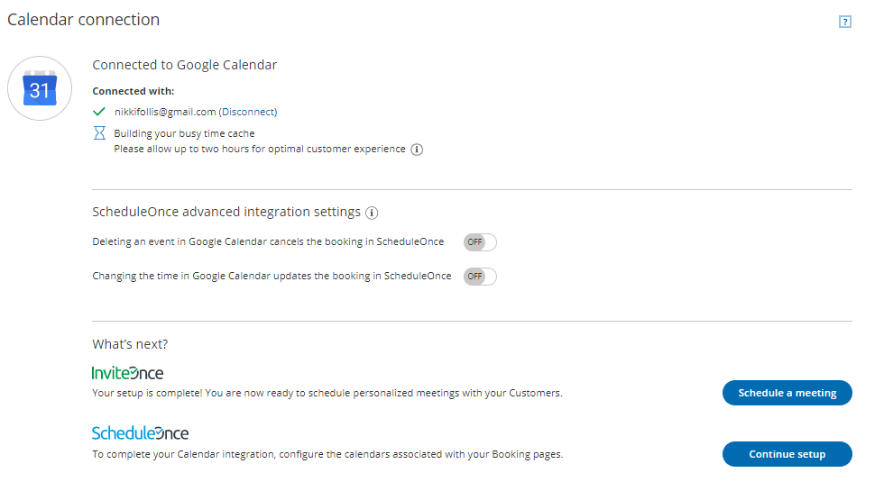
- Click the plus sign to the right of the Booking Pages
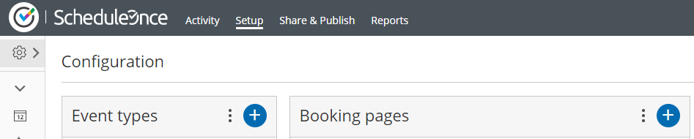
- Enter your information into the boxes (choose your name for the Owner), Be sure to Select the 15-Minutes Welcome Call for the Event Type, and then Save & Edit:
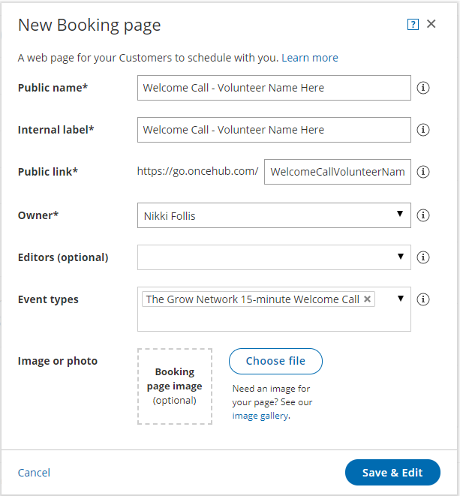
- Then select Recurring Availability or Date Specific Availability to setup your schedule.
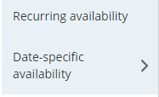
- Once you setup your availability, select Save.

For Those Not Connecting a Personal Calendar – Follow these Steps:
- Click on Setup
- Click the plus sign to the right of the Booking Pages
- Enter your information into the boxes (choose your name for the Owner), Be sure to Select the 15-Minutes Welcome Call for the Event Type, and then Save & Edit:
- Then select Recurring Availability or Date Specific Availability to setup your schedule.
- Once you setup your availability, select Save.

